## Technical assignment

You have developed a software that has the following data entry form:

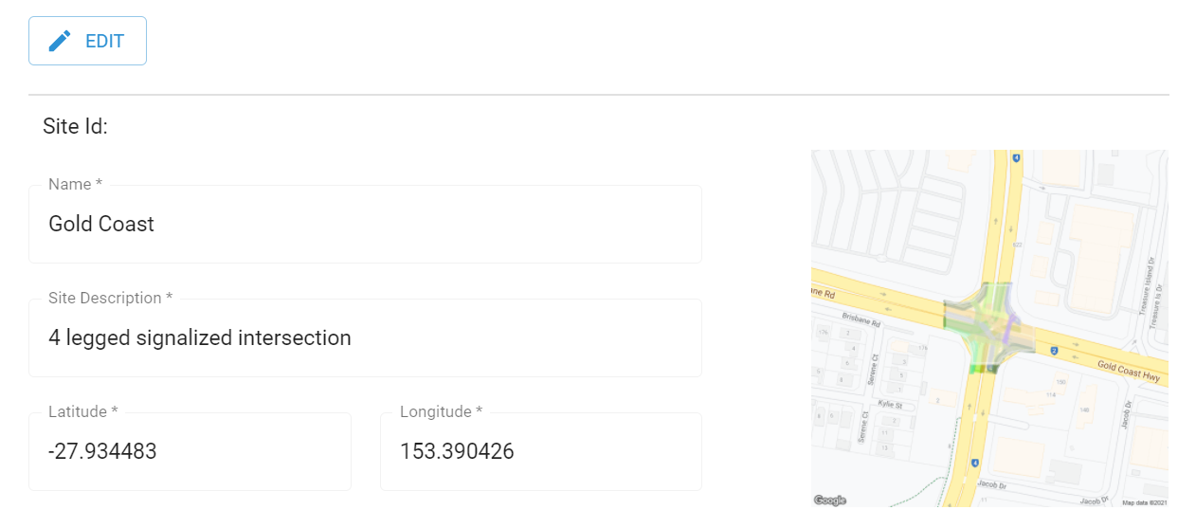

Now you are to add a new feature to your software where users can import this information from a spreadsheet. But the spreadsheet has no specific format.

As a front end developer, you are thinking to create a visualisation tool where users will upload a spreadsheet. The system will then load the file in the UI and let the user select the form field and pick a specific cell value from the spreadsheet.

Screen 1:

| SMART IMPORT |
| --- |
| Upload your spreadsheet to start.. |

Screen 2:

| SMART IMPORT |  |
| --- | --- |
| Site Information  Select a field | Uploaded spreadsheet  Please pick a cell to assign value |